**Project Design Phase-II**

**Data Flow Diagram & User Stories**

|  |  |
| --- | --- |
| Date | 4 November 2022 |
| Team ID | PNT2022TMID10908 |
| Project Name | Nutrition Assistant Application |
| Maximum Marks | 4 Marks |

**Data Flow Diagrams:**

A Data Flow Diagram (DFD) is a traditional visual representation of the information flows within a system. A neat and clear DFD can depict the right amount of the system requirement graphically. It shows how data enters and leaves the system, what changes the information, and where data is stored.

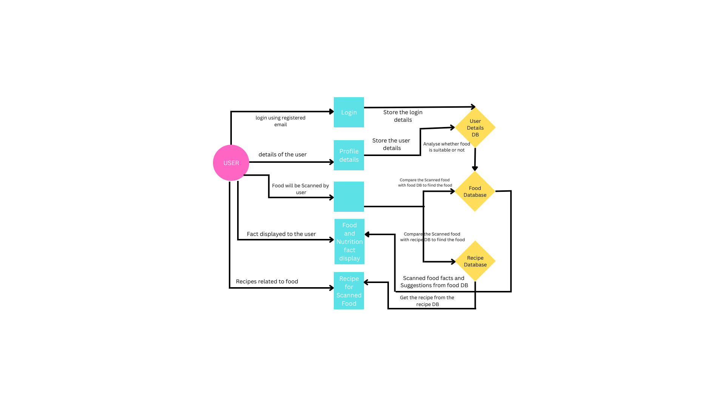

**User Stories**

Use the below template to list all the user stories for the product.

|  |  |  |  |  |  |  |
| --- | --- | --- | --- | --- | --- | --- |
| **User Type** | **Functional**  **Requirement**  **(Epic)** | **User Story Number** | **User Story / Task** | **Acceptance criteria** | **Priority** | **Release** |
| Customer | Registration | USN-1 | As a user, I can register for the application by entering my name, age, gender, e-mail, password and confirming my password | I can access my account / dashboard | High | Sprint-1 |
|  | Registration | USN-2 | As a user, I will receive confirmation email once I have registered for the application | I can receive confirmation email & click confirm | Medium | Sprint-1 |
|  | Profile Updating | USN-3 | As a user, I have to enter my height, weight and daily activity details | I can update this information on dashboard | High | Sprint-1 |
|  | Login | USN-4 | As a user, I can login to the application through Gmail with login credentials | I can access my account / dashboard | Medium | Sprint-2 |
|  | Database | USN-5 | As a user, I can upload or capture live image of the meal | I can get the nutritional value of that particular meal | High | Sprint-2 |
|  | Dashboard | USN-6 | As a user, I can track my daily calories intake | I can access my account / dashboard | Medium | Sprint-2 |
| Administrator | Maintaining details for users | USN-7 | Maintaining details for users | I can access database | High | Sprint-3 |
|  | Security | USN-8 | As a user, I feel the site is very secure | I can access my account with my login credentials | High | Sprint-3 |